MLA0303-Reinforcement Learning
CO-1 AT-1
Descriptive Experiment
Name: Ch. Venkata Lakshmi Hymavathi
Reg No: 192425397
Experiment 1: Installation of Reinforcement Learning Development Environment Aim
To verify the Reinforcement Learning development environment using Gymnasium in Jupyter Notebook.
Algorithm/Procedure
1. Open Jupyter Notebook.
2. Import the Gymnasium library.
3. Create the FrozenLake environment.
4. Print a success message.
5. Verify that the environment is created successfully. Program import gymnasium as gym
env = gym.make("FrozenLake-v1")
print("Environment created successfully!")
Output
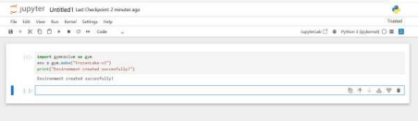Result
The Reinforcement Learning environment was verified successfully.
Experiment 2: Familiarization with OpenAI Gym/Gymnasium
Aim
To create and interact with the FrozenLake environment using Gymnasium. Algorithm/Procedure
1. Import the Gymnasium library.
2. Create the FrozenLake environment.
3. Reset the environment to get the initial state.
4. Take random actions.
5. Display the state, action and reward.
6. Close the environment. Program import gymnasium as gym env = gym.make("FrozenLake-v1")
state, info = env.reset()
print("Initial State:", state)
for i in range(5):
action = env.action_space.sample() state, reward,
terminated, truncated, info = env.step(action)
print("Step:", i+1)
print("Action:", action)
print("Next State:", state)
print("Reward:", reward)
env.close()
Output
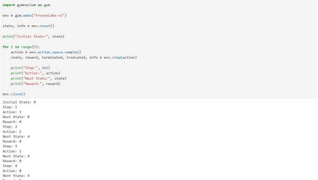Result
Successfully interacted with the FrozenLake environment.
Experiment 3: Implementation of the Reinforcement Learning Framework Aim To implement a basic Reinforcement Learning framework using an agent and environment. Algorithm/Procedure
1. Import Gymnasium.
2. Create the FrozenLake environment.
3. Reset the environment.
4. Select random actions.
5. Display the current state, action and reward.
6. Continue until the episode ends. Program import gymnasium as gym env = gym.make("FrozenLake-v1")
state, info = env.reset()
done = False
while not done:
action = env.action_space.sample()
next_state, reward, terminated, truncated, info = env.step(action)
print("State:", state)
print("Action:", action)
print("Reward:", reward) state
= next_state done =
terminated or truncated
env.close()
Output
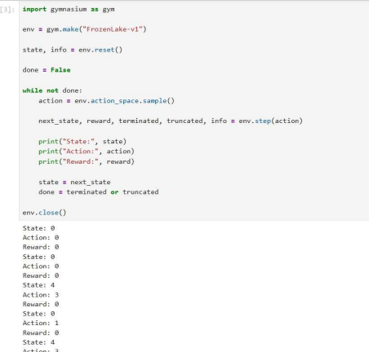Result
The Reinforcement Learning framework was implemented successfully. Experiment 4: Simulation of a Markov Decision Process (MDP)
Aim
To simulate a simple Markov Decision Process using states and rewards. Algorithm/Procedure
1. Define the states.
2. Set the initial state.
3. Move from one state to another.
4. Assign rewards.
5. Stop when the goal state is reached. Program states = ["Start", "Middle", "Goal"]
current = 0
while current < len(states)-1:
print("Current State:", states[current])
reward = 0
current += 1
print("Current State:", states[current])
print("Reward: 10") print("Goal
Reached")
Output
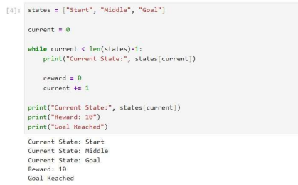Result
The Markov Decision Process was simulated successfully.
Experiment 5: Bellman Equation Demonstration
Aim
To demonstrate the Bellman Equation for calculating the value of a state. Algorithm/Procedure
1. Define the reward.
2. Define the discount factor.
3. Define the next state value.
4. Apply the Bellman Equation.
5. Display the calculated state value. Program
reward = 5 gamma =
0.9
next_state_value = 10
value = reward + gamma * next_state_value
print("Reward =", reward) print("Discount
Factor =", gamma) print("Next State Value
=", next_state_value) print("Current State
Value =", value)
Output
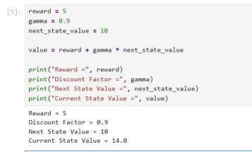
Result
The Bellman Equation was implemented successfully to calculate the state value.

